Name of the project:

Name of the applicant:

Unit/Institute:
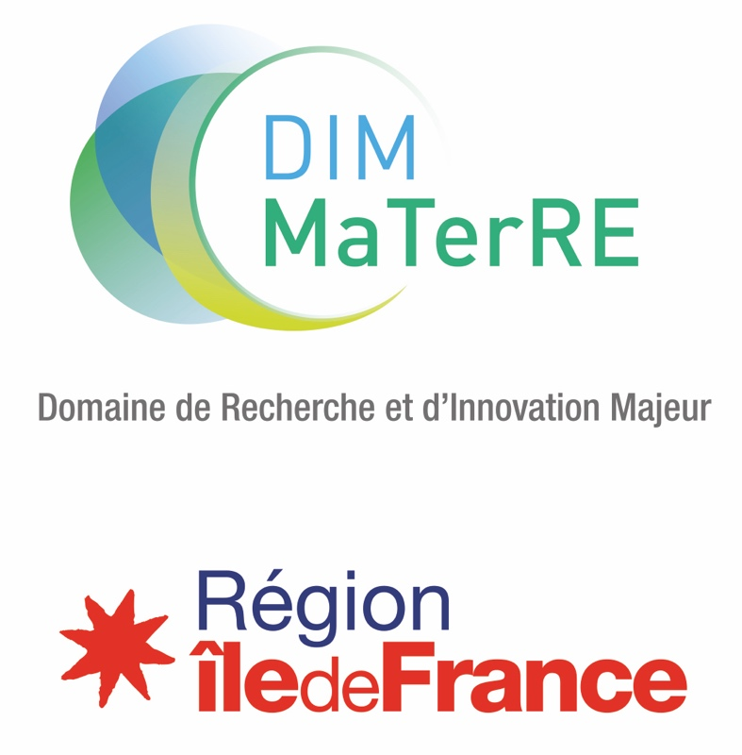

Permanent Call for proposals INTERNATIONAL
MISSIONS AND VISITS

Funding under 5000 k euros

Files should be submitted on the dedicated platform at the following address: https://materre-2024-5.sciencesconf.org

Contact: dim-materre@espci.psl.eu
OBJECTIVE
The aim of this call for proposals is to promote the construction of lasting scientific relationships between Ile-de-France laboratories and international laboratories, in order to advance research in the field of advanced eco-responsible materials.

ELIGIBILITY
Eligible projects are carried out between team members of labs working on MaTerRE axes. Any Paris Region lab is eligible, without prior affiliation to the DIM. The submission of a project will be considered as an application for affiliation to the DIM.
Proposals for international missions and visits can be submitted for either incoming or outgoing stays.
Can be supported :
- Doctoral missions
- Invited professors / Chairs (teaching activities, conference, lab visit).
Travelling persons are either a member of DIM MaTerRE’s lab or a guest, and may be either Professors, researchers, PhDs or post-doctoral fellows.
There are no restriction on duration or distance. However, the carbon impact of the mission will be put into perspective with the scientific interest. For a long-distance mission over a short period of time, argument on the scientific relevance and the absence of an alternative is expected.
Eligible costs cover business trips expenses included in the travel towards the international host institution, as well as local subsistence costs. Registration fees at a congress are not eligible.
PLEASE NOTE: Applications must be submitted at least 3 months before travelling.
THEMES
The DIM MaTerRE is centered around four thematic axes, corresponding to current scientific, technological and societal challenges:
  - Capture, Production and Valorisation of strategic gases (CO₂, H₂…).
  - Eco-compatible Energy Storage or recovery.
- Construction materials.
  - Recycling, eco-design, sustainable materials, urban mining
This is complemented by 5 transverse methodological axes, including High-throughput methodologies (microfluidics…), Architected and multiscale materials, Advanced characterization techniques, numerical methods (databases, artificial intelligence, numerical modelling, simulations…), Economics of the energy transition.
Proposals funded by MaTerRE have to fit within at least one, preferably two, of these axes.

EVALUATION CRITERIA
The evaluation criteria are the following:
  - Novelty and quality of the collaboration, in terms of complementarity and expected synergy.
  - Scientific interest and global relevancy of the mission for the laboratory
  - Link between the Project and MaTerRE’s themes
  - Benefits for MaTerRE’s network and Paris Region (invited Prof., open conf, etc.)
  - Relevancy in the beneficiary’s work or career (student’s thesis, researcher current projects, etc.)
  - Relevance and quality of the co-funding plan.
CALENDAR
Projects can be submitted at any time of the year on the dedicated platform: https://materre-2024-5.sciencesconf.org/

LANGUAGE & FILE NOMENCLATURE
Projects must be written exclusively in English. Files must be named according to the following these rules: MISSION_PROJECTLEADERNAME_FILENAME.

PROJECT DESCRIPTION
Type of mission (please tick the correct option):
Prof./Expert invitation | Doctoral mission
Research chair |  | Other: …………….
Dates of the mission:
Place of the mission:
Purpose of the mission, Program and brieve description (specify teaching activities, organization or participation to workshops)

Scientific interest and relevancy of the mission for the laboratory/beneficiary (if applicable, please justify the necessity of a long distance mission)

Adequacy and integration to the MaTerRE’s axes and goals

IDENTIFICATION OF THE PARTNERS

 | Project leader* | Travelling person (beneficiary** or invitee) | Host (if applicable)
First name LAST NAME
Email
Phone number
Lab name, address and phone number
Team name (if applicable)
Institution name, address and phone number

*Please attach a short resume (max 1 page, including experience, expertise, responsibilities, list up to 5 recent publications, main projects…) of each project leader
**Please attach a short resume of the beneficiary

Have the teams already worked together? ☐ Yes ☐ No

If yes, which one(s) and on which occasion? Indicate how far the proposed project differs from the previous collaborations (novelty, impact – maximum 5 lines).

MaTerRE’s thematic or transverse axis or axes concerned

Thematic axes

☐ Strategic gases
☐ Eco-compatible energies
☐ Construction Materials
☐ Recycling, eco-design, sustainable materials and urban mining

Transverse axes

☐ High-throughput
☐ Architected and multiscale Materials
☐ Numerical methods
☐ Advanced characterization
☐ Economics

FUNDING SCHEME

Amount of funding requested

☐ Full funding

☐ Partial funding

Institution in charge of the management of the mission

Envisioned project co-financing.
Please indicate the amount and % of the total cost for each sponsor.
ESTMATED EXPENSES
Expense | Amount
 | - €
 | - €
 | - €
 | - €
Total | - €
FUNDING PLAN
Financing institution | Acquired | Requested | % of the total | Amount
DIM MaTerRE |  | X |  | - €
 |  |  |  | - €
 |  |  |  | - €
 |  |  |  | - €
Total |  |  |  | - €

SIGNATURES

Signature of the project leader

First name, Last name
Position
in
the
Signature

Visa / Signature of the unit director
First name, Last name
Position
in
the
Signature

Signatures are required for the proposals to be accepted.

ANNEX: GENERAL RULES OF THE CALL FOR PROPOSALS MATERRE

Advertency: These rules are likely to be enriched or clarified, on the basis of the Region rules, between now and the award of projects.

The objective of MaTerRE is to generate breakthroughs in sustainable materials for the energy transition, both fundamental and applied, by promoting interactions between specialists from different disciplines.
The aim of this call for proposals is to promote the construction of lasting scientific relationships between Ile-de-France laboratories and international laboratories, in order to advance research in the field of advanced eco-responsible materials.
All the Paris Region teams working in the fields listed in MaTerRE are eligible to respond to the call for proposals (CFP).
In the case where a team applies for several proposals, MaTerRE requests that the unit director in the team establishes a ranking of the proposals.

The selection of proposals will be organized by MaTerRE's steering committee, supported by a jury including experts from outside Paris region.
The proposal must not have been financed by the Region as part of the support for collaborative projects of a competitiveness cluster, nor by another DIM or any other regional funding scheme.
The submitted scientific proposal must not have been proposed in any other DIM’s call for proposals.
FINANCING
The grant may take into account all travel expenses required for the mission only (transportation, accommodation, subsistence costs, travel taxes). Any management costs of the beneficiary institutions are not eligible for funding.
It will be possible to apply proposals co-financed by one or more partners.

ENGAGEMENT OF THE TEAMS

The recipient teams of a grant of the Paris Region, within the framework of a MaTerRE Call for Proposals, commit to, in particular:
- To read and respect the regional and MaTerRE rules.
- To transfer the progress report (s), the activity report of the project or any other document at the request of the administrative department of the ESPCI, MaTerRE's managing institution, respecting the indicated deadlines and document formats.
- To indicate, in the context of any written publication (article, proceedings ...), the following thank-you text: "This work has been sponsored by the Ile-de-France Region in the framework of MaTerRE”.
- To display, as part of any oral communication (conference, seminar, workshop, school ...) the logo of the Ile-de-France Region and that of MaTerRE and its guardianships.

DATA MANAGEMENT

In accordance with Article 13 of the Regulation of the European Parliament and of the Council on the protection of individuals with regard to the processing of personal data and on the free movement of data, and repealing Directive 95/46/EC - Personal Data Protection Policy, the purpose of this policy is to inform you about the processing of personal data that you share with us.
Type of data collected: only personal and non-sensitive data are collected.
Personal data communicated through the project deposal or affiliation form will be used by MaTerRE instances in order to communicate about DIM MaTerRE actions. These personal data could be communicated to experts to perform the evaluation of your project. Experts will delete all your personal data at least one month after the end of the evaluation.
If you submit a proposal, we may also contact you to ask for complementary information or give you information about the steps of the call for proposals.
Data will be retained for the duration of the program. At any moment, you can contact dim-materre@espci.psl.eu to modify or erase your information.
In accordance with the general data protection regulation (EU) 2016/679, to data processing, files and freedoms, you have the right to access, rectify, delete your personal data, to request its portability, or to limit its processing.
In the case your project receive funds from DIM MaTerRE through a call for proposals, we may also contact you for all requirements linked to the project (administrative, communication, scientific purposes). As DIM MaTerRE is funded by Ile de France Region, we will communicate your information to the research department of Ile de France Region in the framework of DIM MaTerRE program management and reports. In that case, your data will be retained for the regional contract duration (10 years). At any moment, you can contact dpo@iledefrance.fr and dpo@espci.psl.eu to modify or erase your information.

See details in annex.

